Primary Supply List 2023-2024 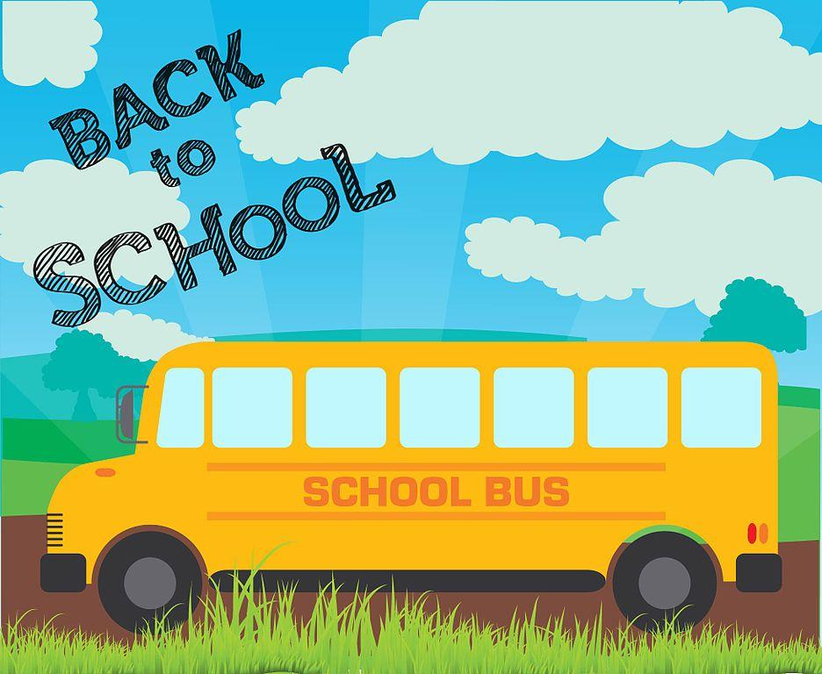
Amount | Item
20 | Hp pencils (sharpened)
2 | Boxes of 24 Crayola crayons
4 | White glue sticks
1 | Pair of children scissors
1 | Pencil case
3 | 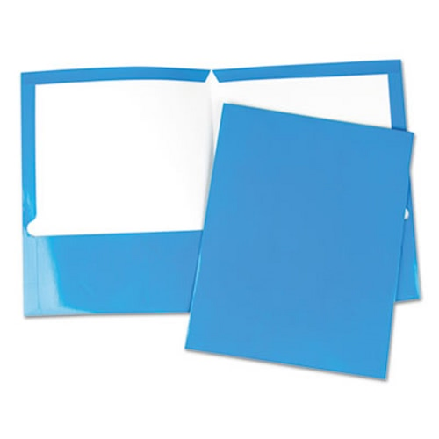  Pocket folders  (1 orange, 1 yellow, 1 blue)
4 | White erasers
3 | Exercise notebooks (yellow cover ½ lined on bottom top ½ no lines) 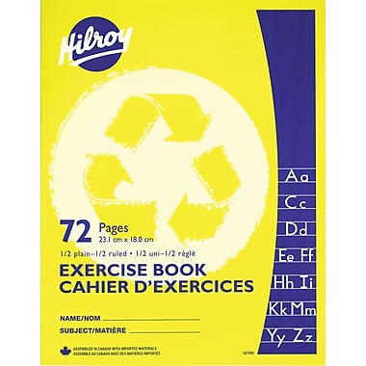
1 | Exercise notebook (blue cover with plain white paper) 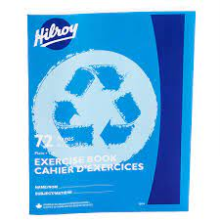
4 | Duo tangs (1 red, 1 blue, 1 yellow , 1 orange)
1 | Box of 8 thin tip markers (Crayola suggested)
12 | Whiteboard markers (Expo)
1 | Cloth, clean sock, or a piece of felt to clean whiteboard
1 | Pair of indoor shoes to be left at school. Velcro if your child can not tie their own shoes.

Optional
1 box of large zip lock baggies
2 boxes of Kleenex
1 extra set of clothing in a ziplock baggie
Please label all of your child's supplies and clothing.

