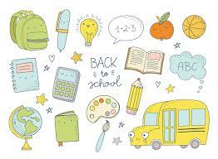
Grade One Supply List
September 2023

Amount | Item
20 | HB Pencils (pre-sharpened)
1 | Pencil box 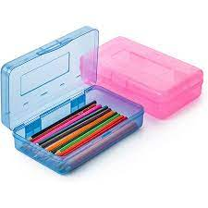
1 | Pencil sharpener
12 | Expo Whiteboard markers
1 | Cloth, piece of felt, or a sock to clean whiteboard
3 | Boxes of Crayola crayons
4 | Glue Sticks (white)
1 | Pair of child scissors
3 | 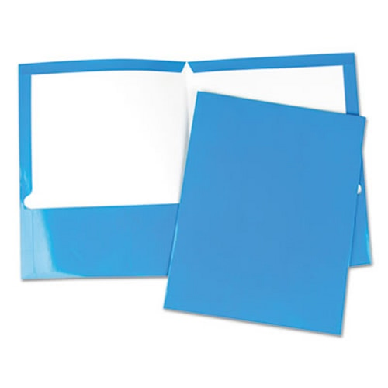  Two pocket folders (yellow, blue, orange)
4 | Duotangs (yellow, red, blue, orange)
4 | White erasers
3 | Hilroy 72 pages Exercise Book (yellow cover) ½ plain on top and ½ lined on bottom of pages 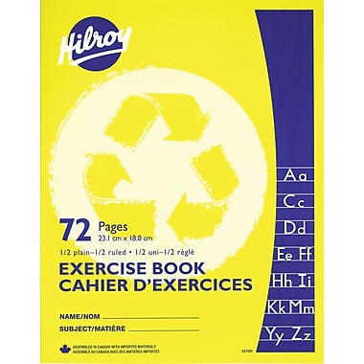
2 | Boxes of Crayola markers (thin tipped)
1 | Messenger Bag (can be found at the Dollar Store with a zipper)
1 | Bottle of white glue
1 | Pair of indoor shoes to be left at school. Velcro if your child can not tie their own shoes.

Optional supplies
-2 boxes of Kleenex, large ziplock bags, headphones to wear when using technology
Please label all of your child's supplies and clothing.
***The first day of school is very busy! We need your help in keeping us organized. ***
1. Please help by taking all items out of their plastic packaging and label with your child’s name or initials.

2. Please fill your child’s pencil box with the following items and send it the first day of school...
Scissors
2 Glue sticks
1 Eraser (cut in half)
1 Box of crayons
8 Sharpened pencils
1 Pack markers
2 White board markers
1 White board eraser (a cloth, piece of felt, or clean sock is fine)
Pencil sharpener
3. Please place the rest of the items in a Ziplock bag and send them along with the pencil box on the first day of school. Please put your child's name on the Ziplock bag and on all of the other individual supplies.

