Bell Park Academic Center
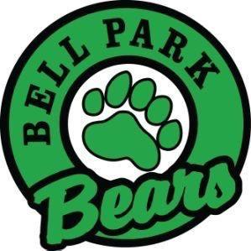
Grade 2 School Supply List 2023

4 duo-tangs (1 of each color- blue, yellow, green, black) | 1 whiteboard eraser (a rag or clean sock is fine)
3 plastic pocket folders | 3 large or 6 small glue sticks
1 pkg. of Hilroy exercise scribblers (no coil bindings) | 2 pkg of 4 whiteboard markers for use with personal whiteboard
2 Hilroy 72 pg. yellow exercise scribbler ½ plain ½ lined. | 1 pair of scissors
2 boxes of 24 crayons | 4 pkg of quality HB pencils
1 pkg of colored pencils | 1 pencil box/container for supplies
1 pkg of regular markers | 2 white erasers
2 black Sharpies | 1 zippered courier bag
1 pencil sharpener (with attached container) | For Phys. Ed. 1 Pair of sneakers (for indoor use, to be left at school)

Optional:
2 boxes of tissue
1 water bottle
1 container of playdough
2 boxes of Ziploc-style bags (one large and one medium)
1 set of headphones for use with Chromebooks
------------------------------------------------------------------------------------------------------
***The first day of school is very busy! We need your help in keeping us organized. ***
- Please help by removing all items from their plastic packaging and labeling them with your child’s name or initials.

- Please fill your child’s stash box with the following and send it on the first day of school...

1 pair of scissors
2 glue sticks
1 eraser (cut in half)
1 box of crayons
8 sharpened pencils

1 pack Markers
2 whiteboard markers
1 whiteboard eraser (a rag or clean sock is fine)
1 pencil sharpener

- Please place the rest of the items in a Ziplock bag and send them along with the pencil box on the first day of school. Please put your child's name on the Ziplock bag and on all the other individual supplies.

These school supplies are intended to last the students most of the year, however, you may be asked to replenish some items throughout the year such as pencils, markers, whiteboard markers, and glue. Before going shopping, please check your child’s supplies from last year, as they may not need everything on the list.

Thank you! ☺

