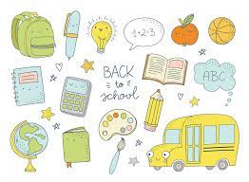
Grade 1/2 French Immersion Supplies
Bell Park September 2023

Amount | Item
20 | HB Pencils (pre-sharpened, please)
1 | Package of 4 whiteboard markers for student use on mini whiteboards
2 | Packages of (24) Crayons (Crayola suggested)
3-4 | Large Glue Sticks
1 | Pair of Scissors
4 | Pocket Folders (all black)
4 | Duotangs – 1 red, 1 yellow, 1 blue, 1 orange
2 | White Erasers
1 | Soft shelled pencil case
3 | Exercise Scribblers (with yellow cover)  ½ plain on top / ½ lined on bottom
1 | Box of thick tip Markers (Crayola suggested)
1 | Box of thin tip Markers (Crayola suggested)
1 | Messenger bag with zipper (can be found at the dollar store)
1 | 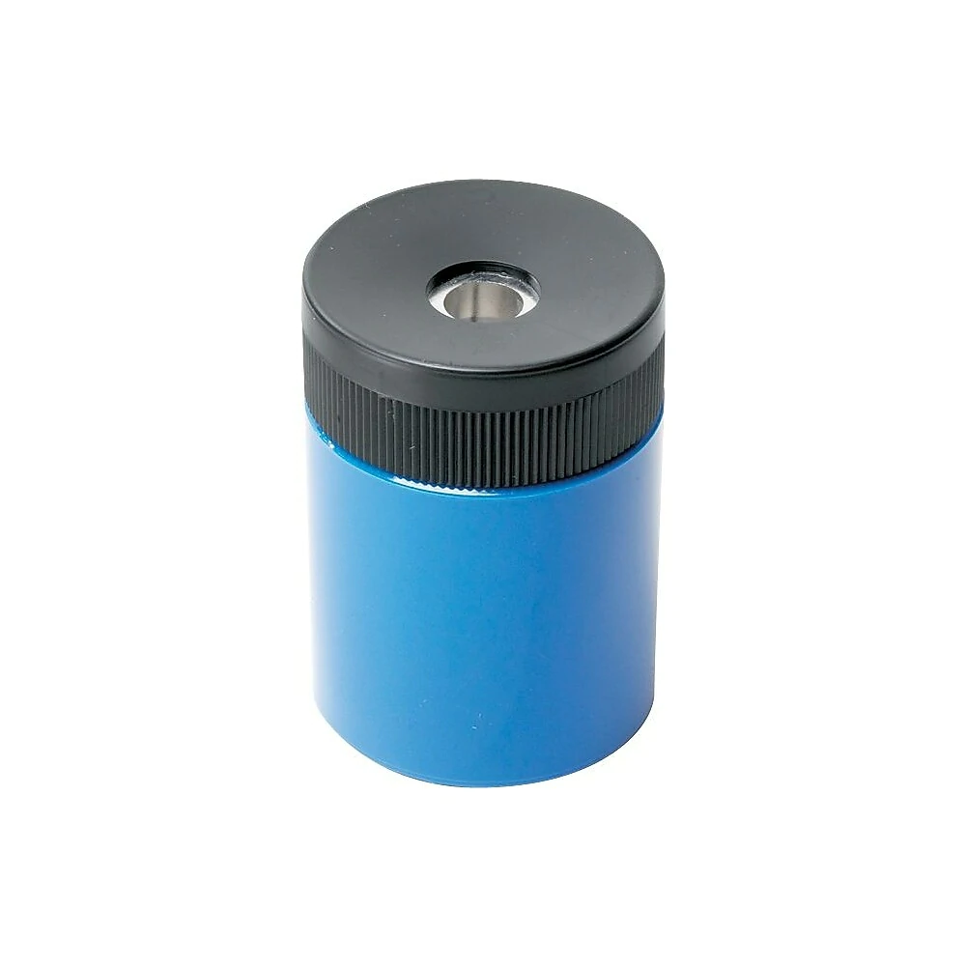  Pencil sharpener
Optional Supplies:
Box of Kleenex and Large ziplock baggies

