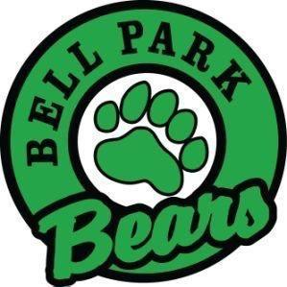
Bell Park Academic Center
Grade 6 School Supply List
1 | 3 inch ring binder
4 pkg | HB pencils
1 pkg of 4 | Hilroy scribblers with lines - 80pg
1 pkg | 24 coloured pencils
1 | geometry set
1 | pair of scissors (labelled with name)
1 | 30 cm metric clear ruler
2 | white vinyl erasers
3 | glue sticks (large)
1 | pencil case (soft cloth) (with 3 holes to fit on binder rings)
3 | duotangs (French Immersion only)
1 pkg | pocket portfolios (English only)
2 | highlighters (different colours)
1 | pencil sharpener that holds shavings
1 pkg | dividers
1 pkg | protective sleeves clear (page protectors) (English only)
1 pkg | whiteboard markers
2 | Sharpies (fine tip) (English only)
1 | water bottle (spill proof)
1 | set of headphones (nothing fancy, Dollar store will work) (English only)
1 | pair of indoor sneakers to be left at school
Other items for your consideration:
1 box Kleenex
disinfectant wipes
ziploc bags (sm, md or lg)
Organization of all materials will take place on the first day. All extra materials will be stored in the classroom with the student’s name for later in the year when supplies dwindle.
Thank you so much!

