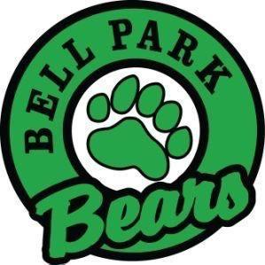
Bell Park Academic Center
Grade 5 School Supply List

3 pkgs | pencils
3 | large glue sticks
1 | pencil case
1 pair | pointed scissors
5 | erasers (white rubber work best)
1 | pencil sharpener (that holds shavings)
2 pkgs | washable markers
1 pkg | coloured pencils
10 | whiteboard markers
2 | black Sharpies - 1 fine tip(regular), 1 extra fine tip (pen like) (English only)
2 | twin pocket folders
1 | hard sided composition book (Dollarama)(English only)
4 | 80 pg scribblers(Hilroy)
3 | duotangs (French Immersion)
1pkg | graph paper
2 | highlighters (different colors)
1 pair | indoor sneakers (for use in PE, to be left at school)
1 pair | headphones for use with Chromebooks
1 | spill proof water bottle
1 | 3 inch ring binder (French Immersion Only)
1 pkg | dividers (French Immersion Only)
Optional items for your consideration:
- ziploc baggies (sm, med or lg)
- 2 boxes of facial tissue
- 1 pkg baby wipes and/or disinfectant wipes

You are not required to send in all quantities at the beginning of the year.
Brand names, colours and other preferences in brackets are recommended but not required.
Please do not hesitate to contact the school if you have a financial concern.
Thank you!

