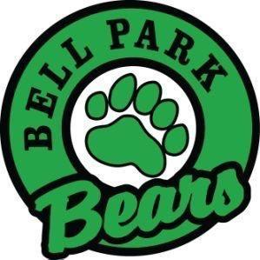
Bell Park Academic Center
Grade 2 School Supply List

4 duo-tangs (1 of each color- blue, yellow, green, other) | 2 whiteboard erasers (a small rag or clean sock is fine)
3 plastic pocket folders | 3 large gluesticks
1 pkg. of Hilroy exercise scribblers (no coil bindings, please) | 12 whiteboard markers for use with personal whiteboard
3 Hilroy 72 page yellow exercise scribbler ½ plain ½ lined. | 1 pair of scissors
2 boxes of the 24 pack of crayons | 10-20 quality HB pencils
1 pkg of colored pencils | 2 boxes of tissue
2 pkgs of regular Crayola 10 pack markers (no minis, please) | 2 white erasers
1 black Sharpie | 1 set of headphones for use with Chromebooks
1 pencil sharpener (with attached container for shavings) | For Phys. Ed. 1 pair of sneakers (for indoor use, to be left at school)

Other items for your consideration:
- 1 water bottle (as we often do not have cups for students)
- 1 pkg baby wipes and/or disinfectant wipes
- 2 boxes of Ziploc-style bags (one large and one medium)
- 1 zippered courier bag

***The first day of school is very busy! We need your help in keeping us organized. ***

- Please help by removing some items from their plastic packaging (example scissors, glue in particular). If you’d like to label your child’s belongings, feel free. You do not need to label singular pencils/markers.

- Please place items in a large bag or Ziploc bag with their name written on the bag. This makes things easier for the first few days of school.

These school supplies are intended to last the students most of the year, however, you may be asked to replenish some items throughout the year such as Kleenex, whiteboard markers and glue. Before going shopping, please check your child’s supplies from last year, as they may not need everything on the list.

Thank you! ☺

